

EAST WEST UNIVERSITY

Assignment

Submitted to:

- Dr. Md. Manowarul Islam

- Adjunct faculty

- Department of Computer Science and Technology

- East West University

Submitted by:

- Name : Rakib Al Hasan

- Student ID : 2024-1-60-143

- Course Title : Data Structure and Algorithm

- Course Code : CSE 207

- Section : 10

- Semester : Summer 2025

- Date of Submission : 30.08.2025


___________________________________________________________________________
- Write a program in to insert a new node at the beginning of a linked list and display the Linked list

Sample Input | Sample Output
Input element: 10  Input element: 20  Input element: 30 | 10  20 10  30 20 10

#include<stdio.h>
#include<stdlib.h>

struct Node
{
int data;
struct Node *link;
};

struct Node *head = NULL;

void insertAtBeginning(int item)
{
struct Node *node = (struct Node*) malloc(sizeof(struct Node));
if(node == NULL)
{
printf("\tMemory allocation failed\n");
return;
}
node->data = item;
node->link = head;
head = node;
}

void display()
{
struct Node *temp = head;
printf("\n\tLink list contains : ");
while(temp != NULL)
{
printf("\t%d", temp->data);
temp = temp->link;
}
printf("\n");
}

int main()
{
int n, item;
printf("\tEnter how many elements you want to insert : ");
scanf("%d", &n);

for(int i = 0; i < n; i++)
{
printf("\n\tEnter new elements : ");
scanf("%d", &item);
insertAtBeginning(item);
display();
}
return 0;
}

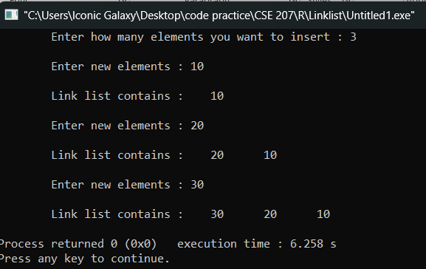

- Write a program in C to find a specific element of a singly linked list. If not found then insert that key value that the middle of the Linked list (Create a linked list first. Insert at the end of the linked list for creating)

Sample Input | Sample Output
Linked List elements:  10 20 30 40 50  Search key: 40 | Element is found
Linked List elements:  10 20 30 40 50  Search key: 70 | Not Found  70 Inserted at the middle  10 20 70 30 40 50

#include<stdio.h>
#include<stdlib.h>

struct Node
{
int data;
struct Node *link;
};

struct Node *head = NULL;

void insertAtEnd(int item)
{
struct Node *node = (struct Node*) malloc(sizeof(struct Node));
node->data = item;
node->link = NULL;
if(head == NULL)
{
head = node;
}
else
{
struct Node *temp = head;
while(temp->link != NULL) temp = temp->link;
temp->link = node;
}
}

int countNodes()
{
int count = 0;
struct Node *temp = head;
while(temp != NULL)
{
count++;
temp = temp->link;
}
return count;
}

void insertAtMiddle(int item)
{
int pos = countNodes() / 2;
struct Node *node = (struct Node*) malloc(sizeof(struct Node));
node->data = item;

struct Node *temp = head;
for(int i = 1; i < pos; i++) temp = temp->link;
node->link = temp->link;
temp->link = node;
}

int search(int key)
{
struct Node *temp = head;
while(temp != NULL)
{
if(temp->data == key)
{
return 1;
}
temp = temp->link;
}
return 0;
}

void display()
{
struct Node *temp = head;
while(temp != NULL)
{
printf("\t%d", temp->data);
temp = temp->link;
}
printf("\n");
}

int main()
{
int n, item, key;
printf("\tEnter how many elements you want to insert : ");
scanf("%d", &n);

printf("\n\tEnter the elements : ");
for(int i = 0; i < n; i++)
{
scanf("%d", &item);
insertAtEnd(item);
}

printf("\n\tLinked List elements : ");
display();

printf("\n\tEnter search key : ");
scanf("%d", &key);

if(search(key))
{
printf("\n\tElement is found\n");
}
else
{
printf("\n\tNot Found\n");
insertAtMiddle(key);
printf("\t%d Inserted at the middle\n", key);
}

printf("\n\tLinked List elements : ");
display();

return 0;
}

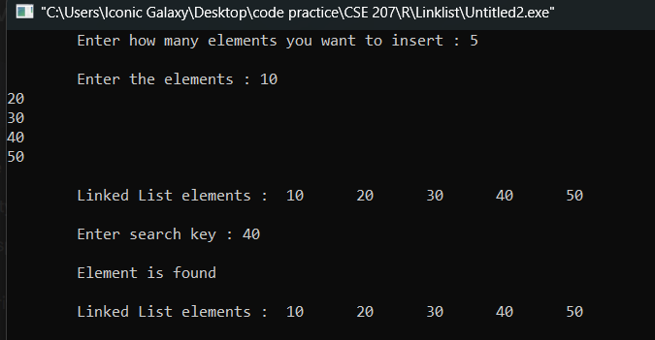

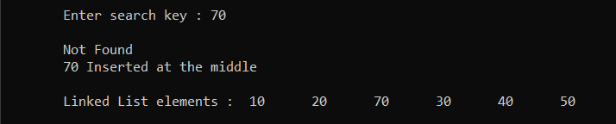

3. Write a program in C to delete from the beginning of a Linked List. (Create the Linked list first)

Sample Input | Sample Output
Linked List elements:  10 20 30 40 50 | 20 30 40 50

#include<stdio.h>
#include<stdlib.h>
struct Node
{
int data;
struct Node *link;
};
struct Node *head = NULL;
void insertAtEnd(int item)
{
struct Node *node = (struct Node*) malloc(sizeof(struct Node));
node->data = item;
node->link = NULL;
if(head == NULL)
{
head = node;
}
else
{
struct Node *temp = head;
while(temp->link != NULL) temp = temp->link;
temp->link = node;
}
}
void deleteFromBeginning()
{
if(head == NULL)
{
printf("\nList is empty!!\n");
return;
}
struct Node *temp = head;
head = head->link;
free(temp);
}
void display()
{
struct Node *temp = head;
while(temp != NULL)
{
printf("\t%d", temp->data);
temp = temp->link;
}
printf("\n");
}

int main()
{
int n, item;
printf("Enter how many elements you want to insert : ");
scanf("%d", &n);

printf("\nEnter the elements : ");
for(int i = 0; i < n; i++)
{
scanf("%d", &item);
insertAtEnd(item);
}
printf("\nLinked List elements : ");
display();
deleteFromBeginning();
printf("\nAfter deletion : ");
display();
return 0;
}
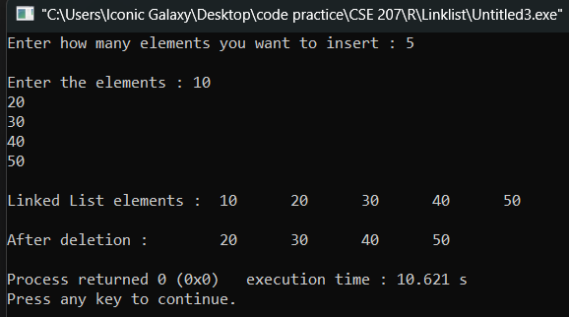

4.Write a program in C to delete the first occurrence of a specific element from a linked list. (Create the Linked list first)

Sample Input | Sample Output
Linked List elements:  10 20 30 20 50 60  Key: 20 | 10 30 20 50 60

#include<stdio.h>
#include<stdlib.h>

struct Node
{
int data;
struct Node *link;
};

struct Node *head = NULL;

void insertAtEnd(int item)
{
struct Node *node = (struct Node*) malloc(sizeof(struct Node));
node->data = item;
node->link = NULL;
if(head == NULL)
{
head = node;
}
else
{
struct Node *temp = head;
while(temp->link != NULL) temp = temp->link;
temp->link = node;
}
}

int deleteKey(int key)
{
struct Node *temp = head, *prev = NULL;
while(temp != NULL && temp->data != key)
{
prev = temp;
temp = temp->link;
}

if(temp == NULL)
{
return 0;
}

if(prev == NULL)
{
head = head->link;
}
else
{
prev->link = temp->link;
}
free(temp);
return 1;
}

void display()
{
struct Node *temp = head;
while(temp != NULL)
{
printf("%d\t", temp->data);
temp = temp->link;
}
printf("\n");
}

int main()
{
int n, item, key;
printf("Enter how many elements you want to insert : ");
scanf("%d", &n);

printf("\nEnter the elements : ");
for(int i = 0; i < n; i++)
{
scanf("%d", &item);
insertAtEnd(item);
}

printf("\nLinked List elements : ");
display();

printf("\nEnter key to delete : ");
scanf("%d", &key);

if(deleteKey(key))
{
printf("\nElement %d deleted successfully.\n", key);
printf("\nAfter deletion : ");
display();
}
else
{
printf("\nElement %d not found. Deletion not possible.\n", key);
}

return 0;
}
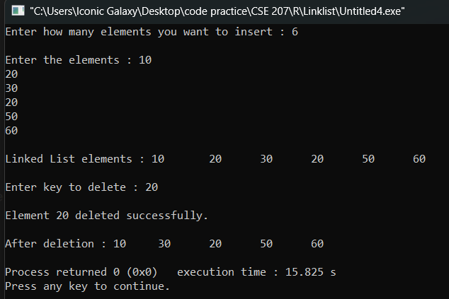

5.Write a program in C to reverse a linked list. (Create the Linked list first)

Sample Input | Sample Output
Linked List elements:  10 20 30 40 50 | 50 40 30 20 10

#include<stdio.h>
#include<stdlib.h>

struct Node
{
int data;
struct Node *link;
};

struct Node *head = NULL;

void insertAtEnd(int item)
{
struct Node *node = (struct Node*) malloc(sizeof(struct Node));
node->data = item;
node->link = NULL;
if(head == NULL)
{
head = node;
}
else
{
struct Node *temp = head;
while(temp->link != NULL) temp = temp->link;
temp->link = node;
}
}

void reverseList()
{
struct Node *prev = NULL, *curr = head, *next = NULL;
while(curr != NULL)
{
next = curr->link;
curr->link = prev;
prev = curr;
curr = next;
}
head = prev;
}

void display()
{
struct Node *temp = head;
while(temp != NULL)
{
printf("\t%d", temp->data);
temp = temp->link;
}
printf("\n");
}

int main()
{
int n, item;
printf("Enter how many elements you want to insert : ");
scanf("%d", &n);

printf("Enter the elements : ");
for(int i = 0; i < n; i++)
{
scanf("%d", &item);
insertAtEnd(item);
}

printf("\nLinked List elements : ");
display();

reverseList();

printf("\nReversed Linked List : ");
display();

return 0;
}
